CURRICULUM VITAE
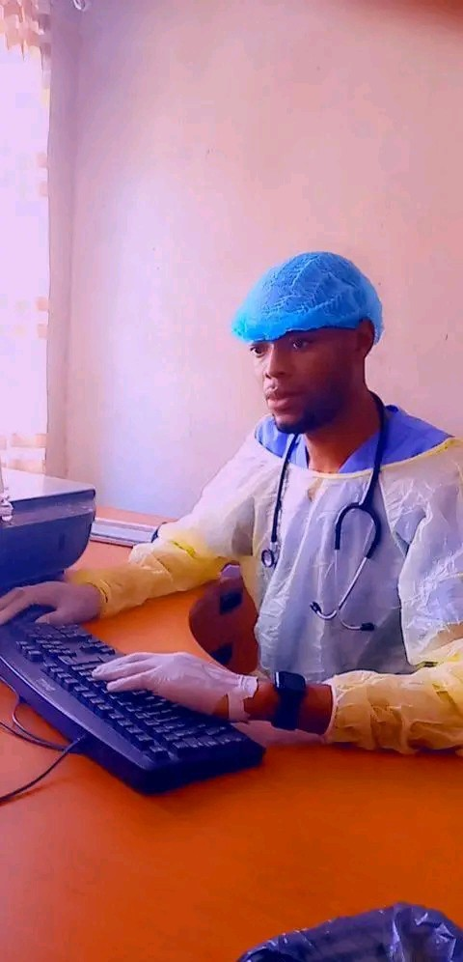
SUMMARY
Looking for an exciting and dynamic role where I can utilize my skills and experience to drive tangible results. Passionate about joining an organization that fosters a culture of innovation, continuous learning, and personal growth.
PERSONAL DETAILS
SURNAME : CHIKOTOLA
FIRST NAME : RASKY
DATE OF BIRTH : 03-07 -1996
SEX : MALE
MARITAL STATUS : SINGLE
RELIGION : CHRISTIAN
N.R.C : 245536/23/1
ADRESS : G-795 NDEKE/KITWE
CELL No. : +260 973857430/ +260 96178511

ACADEMIC QUALIFICATION
DATE SCHOOL CERTIFICATE
2000-2004 KALELA PRIMARY GRADE 1
2004-2006 BUPE BASIC GRADE 4-6
2006- 2009 MUSA PRIVATE G7- CERTIFICATE
2009-2011 NDEKE BASIC G9- CERTIFICATE
2012-2014 MALELA SECONDARY SCHOOL CERTIFICATE
2015-2016. LUNGA DAY HIGH GENERAL CERTIFICATE
2017-2022 RUSANG UNIVERSITY DEGREE IN NURSING
2023-2023 HOPEFIELD SKILLS CENTER HIV/AIDS MANAGEMENT
2023-2023 HOPEFIELD SKILLS CENTER- PSYCHOSOCIAL AND COUNSELLING
2023-2024 INSTITUTE OF BRIGHT VISION OF EXCELLENCE- CERTIFICATES IN HUMAN RESOURCE MANAGEMENT/ PROJECT MONITORING AND EVALUATION.
2023-2024 SHUMBA TRAINING CENTRE LIMITED- CERTIFICATE IN ICT COMPUTER SKILLS
2023-2024 JASPHERSTONE COLLEGE OF APPLIED SCIENCES AND TECHNOLOGY- CERTIFICATE IN SALES AND MARKETING.
2023-2024 SPRING VALLEY COLLEGE OF HEALTH SCINCES, BUSINESS AND TECHNOLOGY- DIPLOMA IN HIV/AIDS MANAGEMENT
2024-2026 SPRING VALLEY COLLEGE OF HEALTH SCINCES, BUSINESS AND TECHNOLOGY- DIPLOMA IN PSYCHOSOCIAL COUNSELLING

WORK EXPERIENCE
YEAR COMPANY/ORGANIZATION/INSTITUTION POSITION
2014 Konkola Copper Mines General Worker
2018-2019 St. Samuel Privates Tuition Centre Teacher
2022 Zambia statistics agency (census) Supervisor
2023 Lupharm pharmacy Drugs supervisor
Stalla Crown School of Health, I worked as a Student Tutor in professional practice, surgery, leaderships management, medicine and paediatrics

Hopefield Skills Centre, I worked less than a year as a part-time lecturer in psychosocial counselling in the year 2023.
Plainview Research Institute, I worked more than a year part-time lecturer in HIV/AIDS management, Rapid HIV Testing, Nursing Assistant.
Heaven Catail College, I worked 1 year as a part-time lecturer in Nursing Assistant, HIV/AIDS management, psychosocial counselling.
I worked at Ndeke Mini Hospital for more than 4 years in all the nursing departments and I worked under indoor residual spraying programmes (IRS) for 2 years under Ministry of Health and Mopani Copper Mine
I worked at Nchelenge Hills College for more than 2 years as a dean of the students and lecturing in TB management, Mental Health, HIV/AIDS management e.t.c
Rokana college of Health Sciences, I worked for more than 6 months part-time lecturer in psychosocial counselling.
I am currently working at Copperbelt Institute of Health and Social Sciences as a part-time lecturer in Public Health Degree.

SKILLS
- Communication Skills
- Creativity
- Teamwork
- Problem-solving and creative thinking
LANGUAGE
- English
- Bemba
- Lunda
HOBBIES
- Reading novels
- Listening to Music
- Playing chess
- Watching movies
- Physical Training
- Cooking
- Writing

FEREENCES
REFERENCE REFERENCE
Chibombwe S.A Rusangu University-Copper Campus
Principal: Mr. SHAOMBA P.O. BOX 22984
Cell: 0955555975 David Mwila House
Email: hopefieldzm@gmail.com Kitwe, Zambia.
Website: https://hopefieldzm.com Cell: +(260)-963467421/ 977929260
Email: admissions-cbc@ru.edu.zm
Website: https://ru.edu.zm/
REFERENCE

NAME: MR. CHISHIMBA
SCHOOL: ROKANA COLLEGE
ADDRESS: Plot no…. 4 3RD STREET NKANA WEST, KITWE NKANA - ZAMBIA
Cell: +260967527301
Email: rokanacollege@gmail.ac.zm
REFERENCE

DIRECTOR: ISAAC MULENGA
SCHOOL: HEAVEN CATAIL CENTRE
CELL: 0770340531
ADDRESS: LUSAKA
EMAI: heavencatail@gmail.com
REFERENCE
DIRECTOR
SCHOOL: PLAINVIEW RESEARCH INSTITUTE
CELL: 0976357494
ADDRESS: LUSAKA
EMAIL: plainviewresearchinstitute94@gmail.com

REFERENCE
DIRECTOR: MR. MOSES LUNGU
SCHOOL: COPPER INSTITUTE OF HEALTH AND SOCIAL SCIENCES
CELL: 0977737309
ADRESS: KITWE CAMPUS; BOWMAKER HOUSE 4TH FLOUR OPPOSITE KITWE LIBRARY
EMAIL: cihss2013@gmail.com
REFERENCE
DIRECTOR: MR. CHISHILA
SCHOOL: NCHELENGE HILLS COLLEGE
CELL: +260978804320/+26096348870
ADDRESS: PLOT NO..LUNCHINDA ROAD, P.O BOX 740020, NCHELENGE- ZAMBIA
EMAIL. nchelengehillscollege@gmail.com
REFERENCE
NAME: MRS AGNESS.I. NALUMINO IN-CHARGE
HOSPITAL: NDEKE MINI HOSPITAL
CELL: +260969791725
ADDRESS: KITWE-NDEKE
PUBLICATION
ASSESSMENT OF KNOWLEDGE AND UTILIZATION OF CERVICAL CANCER SCREENING SERVICES AMONG FAMALE NURSES AT KITWE TEACHING HOSPITAL IN ZAMBIA.

